K.Varshini
192472358
Slot-B
CO2 AT2
AZURE SCREEN SHOTS

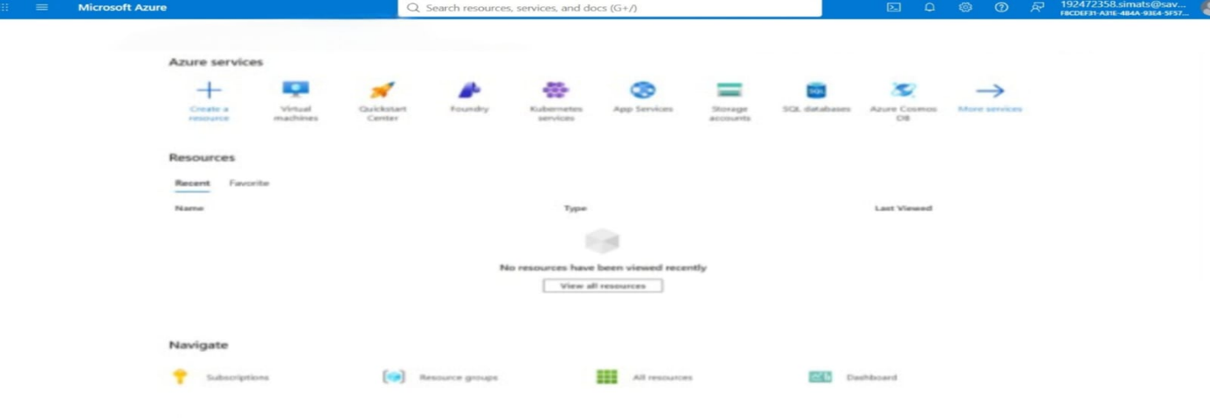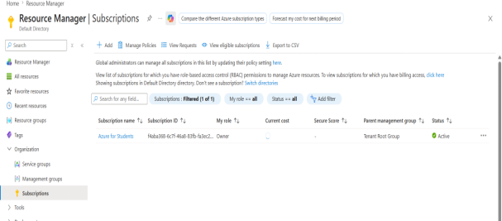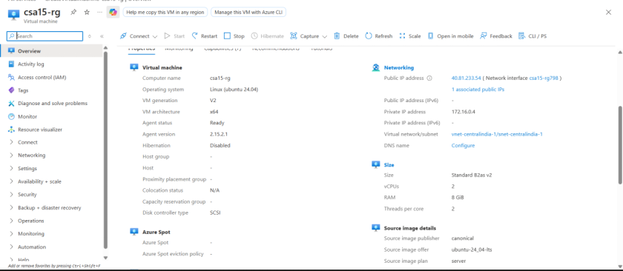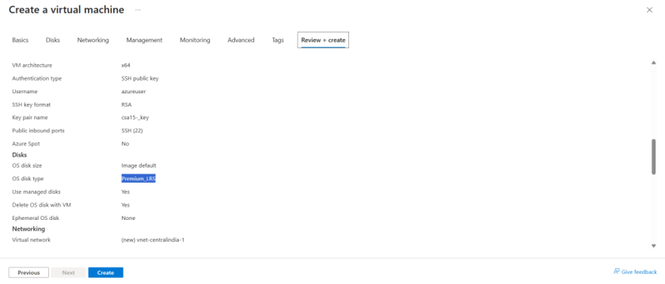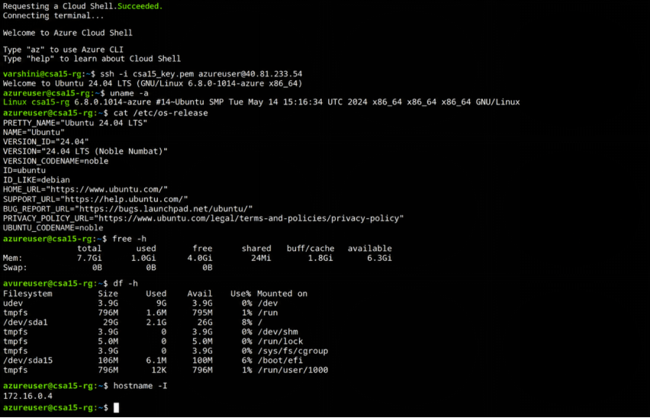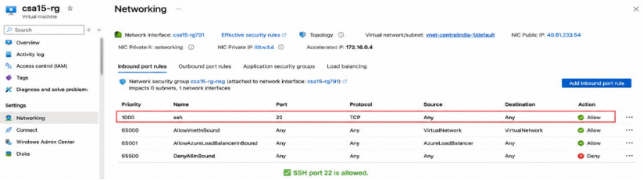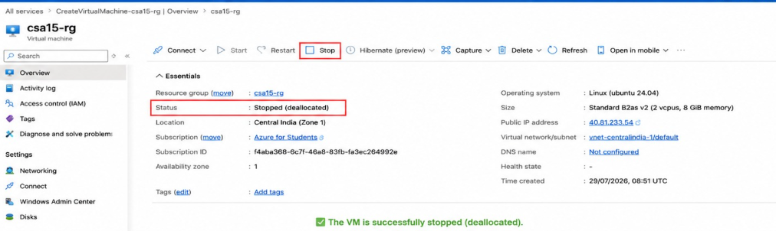
VIRTUAL BOX
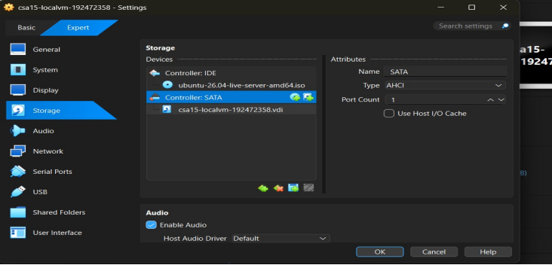
Link used:https://ubuntu.com/download/server
Version:Ubuntu Server 24.04 LTS
Reason:Ubuntu Server provides a secure, stable, and widely used Linux environment for cloud computing, virtualization, Docker, and AI application deployment. It is suitable for the SkillHire capstone project because it supports server-side services, Python, and cloud technologies.
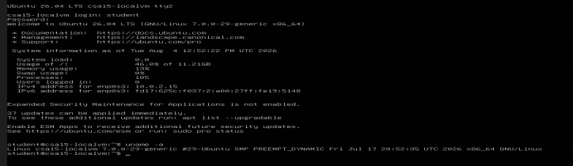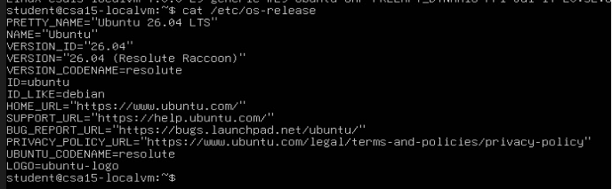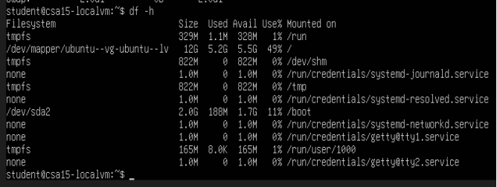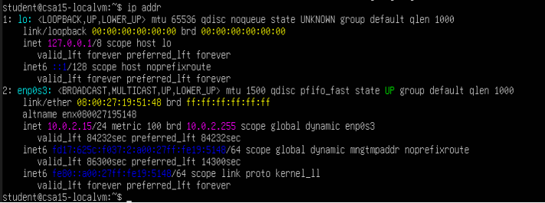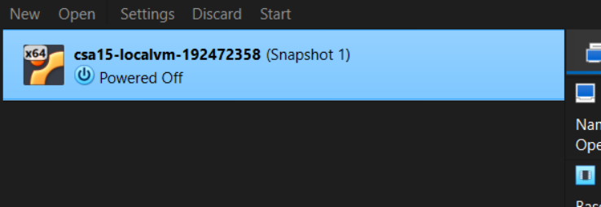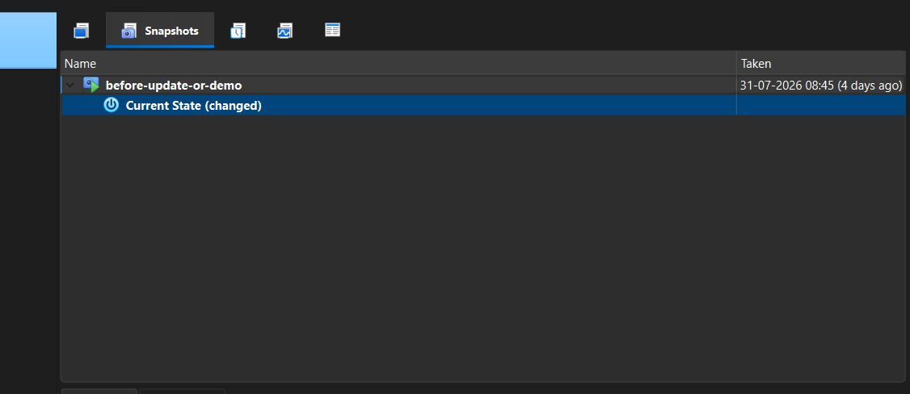
DOCKER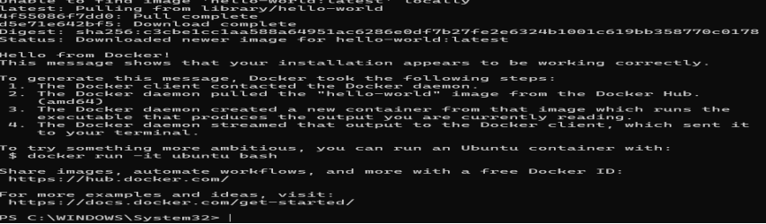
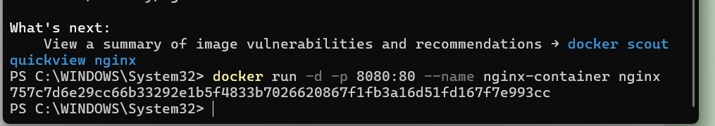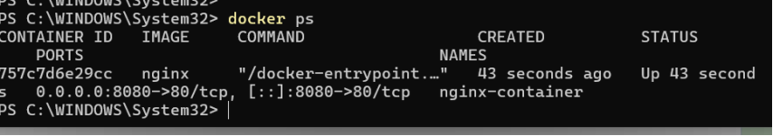
Technical Simulation Path
